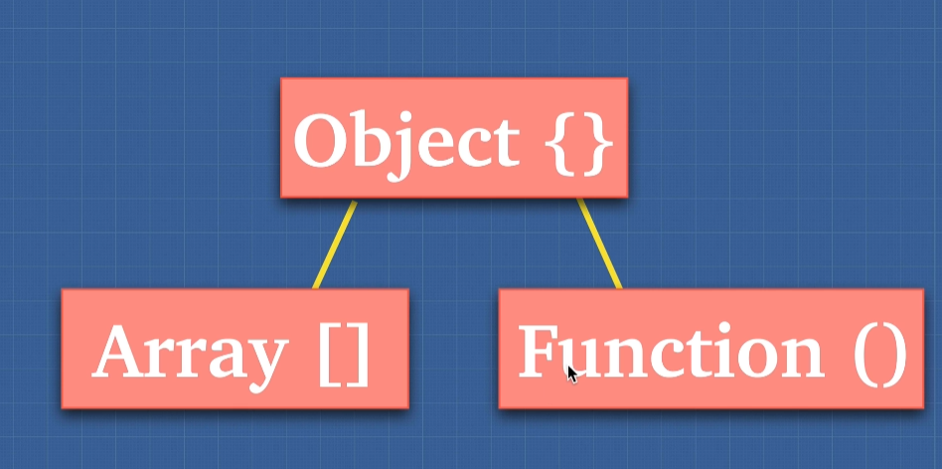

Array and functions are objects.

There is a term saying, everything in JS is object.

Think about this, why we can write true.toString()? there is built in objects in JS

Types in JS can be tricky

Pass by Value vs Pass by References

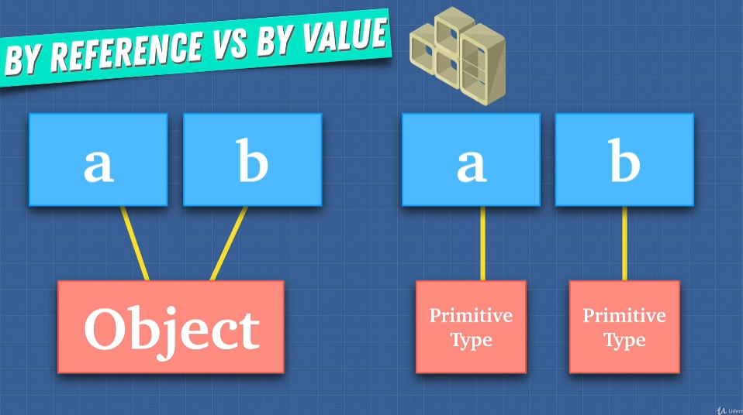

For primitive type, you need to completely remove it from memory when you want to change to new value, they don’t really know their correspond existence

For object, they stored in memory. They don’t copy the value, they simply pass where the reference memory is